IMAGE MACHINE

Image Machine is application android for grouping image. User can create grouping image with choose image from android gallery. User can create and modify data image on this application.

Application specification:

* Java.
* Min SDK 21.
* Target SDK 32.
* Room Database.
* Androidx.
* Glide.
* Yuri-budiev code scanner.
* View Binding.

System requirement:

* API 21 (min Android OS Lollipop).

Application Permission:

* Camera permission.
* Storage Permission.

How to this application work:

1. UseCase Diagram.

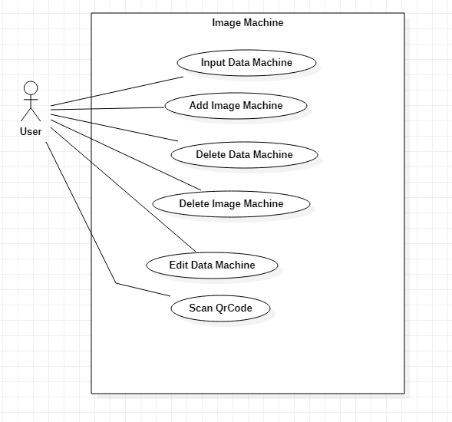

User can Input Data Machine, Add Image Machine, Delete Data Machine, Delete Image Machine,Edit Data Machine, Scan QrCode.

1. Activity Diagram Input Data Machine.

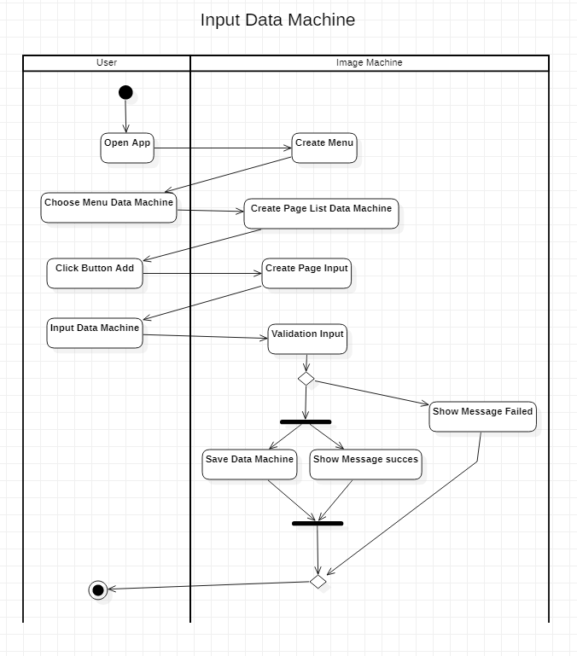

User open the Image machine application and application will show menu. Choose menu data machine and user will go to page list data machine. Click button add will show page input. Then user can input data machine like machine name and machine type. After click input application will check validation input for make sure that machine data has been filled. If some data empty or wrong will show message failed. Then if validation success will save data machine and show image success. User finish for input data machine.

1. Activity Diagram Delete Data Machine.

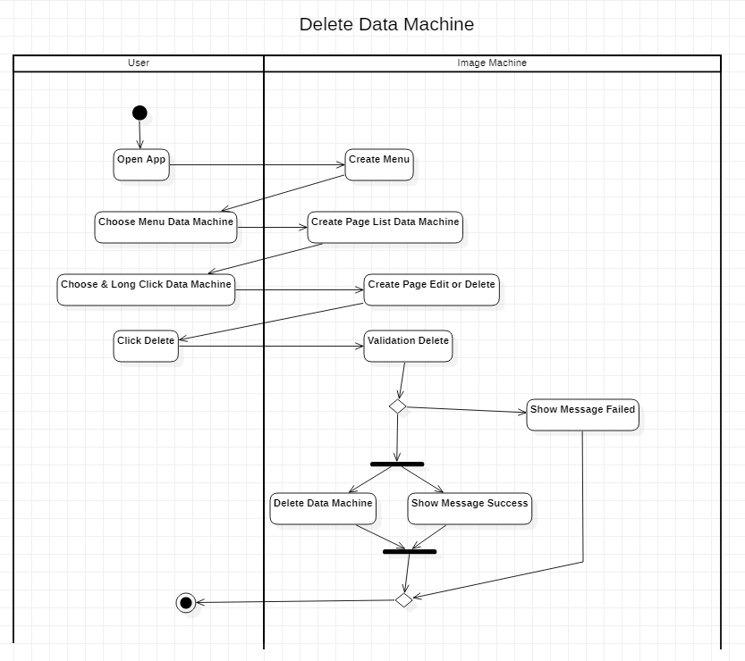

For delete data machine, user open app and application will create menu and user choose menu data machine. After choose data machine user will see list of data machine. Choose and Long click on that data and that application show page edit and delete. Click button delete and then application will validation. If success that data will remove on the application and if not success remove, application will show message failed. User finish do delete data machine.

1. Activity Diagram Edit Data Machine.

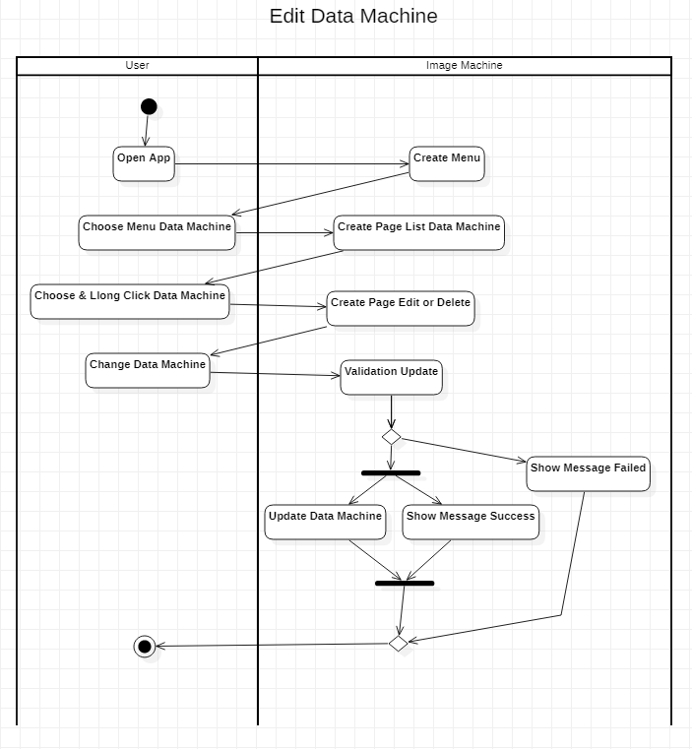

User open the app and then application create menu. Then user choose menu data machine and then application will create page list data machine. User can choose & long click data machine. Then user will go to page edit or delete data machine. User change data machine and after that application will validation update. if validation success will update that data. If update success will show message success and then if update application will show message failed. User finish do edit data machine.

1. Activity Diagram Add Image Machine.

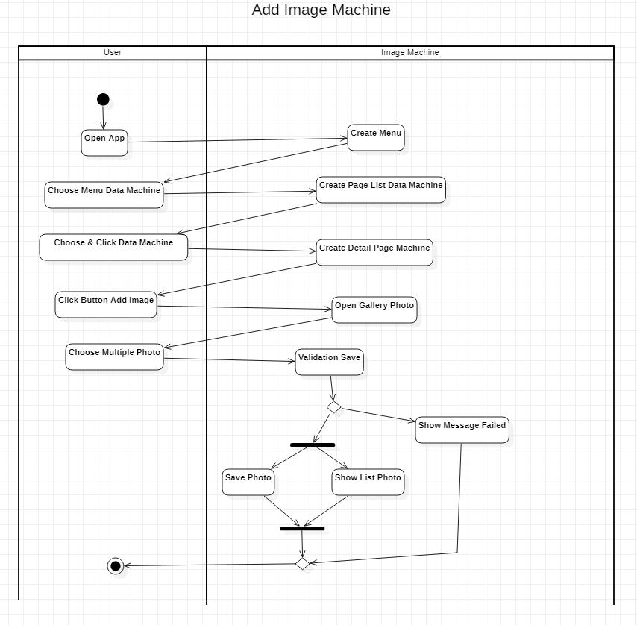 User open the app and then application will create menu. User choose menu data machine and then application will create page list data machine. Choose & long click data machine and application will create detail page machine. User click button add image and then application will open gallery photo. User choose multiple photo. That photo will validation max 10 item image selected. If valdation success photo will save to database and photo will show on detail page machine. And if validation not success will show message failed. User finish do add image machine.

1. Activity Diagram Delete Image Machine.

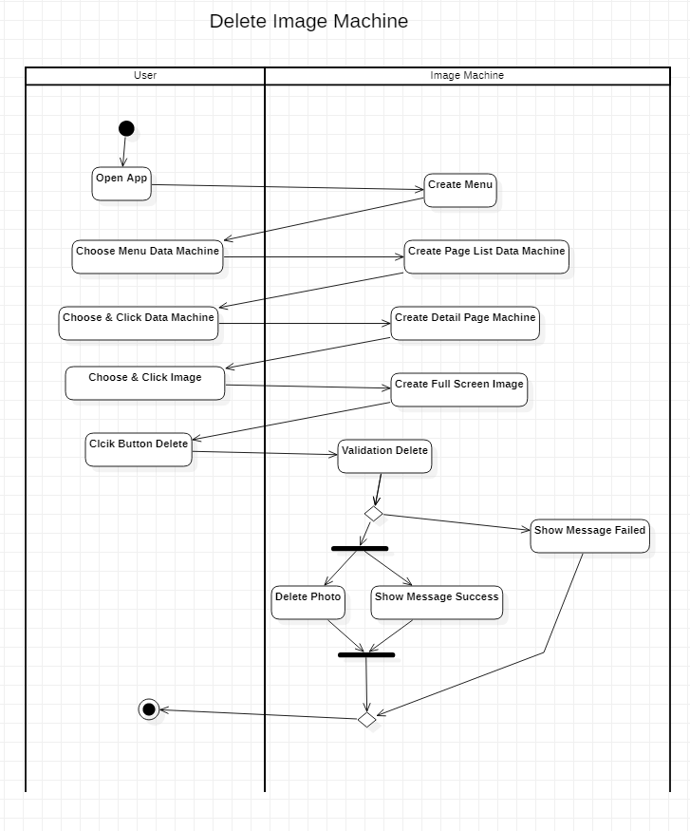

User open the app. The application will create menu. User choose menu data machine. Then application will create page list data machine. User choose & click data machine. Application will create detail page machine. User can choose and click image that will go to full screen image. Click button delete. Before delete image application will do validation for delete. If detele failed application will show message failed. If delete success will show message success. User finish do delete image machine.

1. Activity Diagram Scan QrCode.

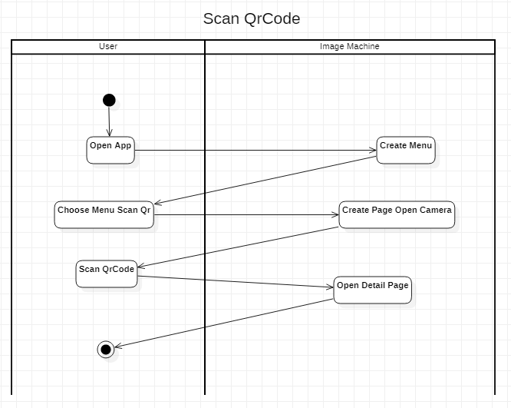

User open app then user will create menu. User choose menu scan qr code. Then create page open camera. Scan qrcode and application will redirect to open detail page. User finish do scan qr code.